WEST GREENLAND GOLD PORTFOLIO
Technical Report Summary | S-K 1300 Compliant
Eqi • Attu • Itilliarsuk Gold Prospects — Central West Greenland
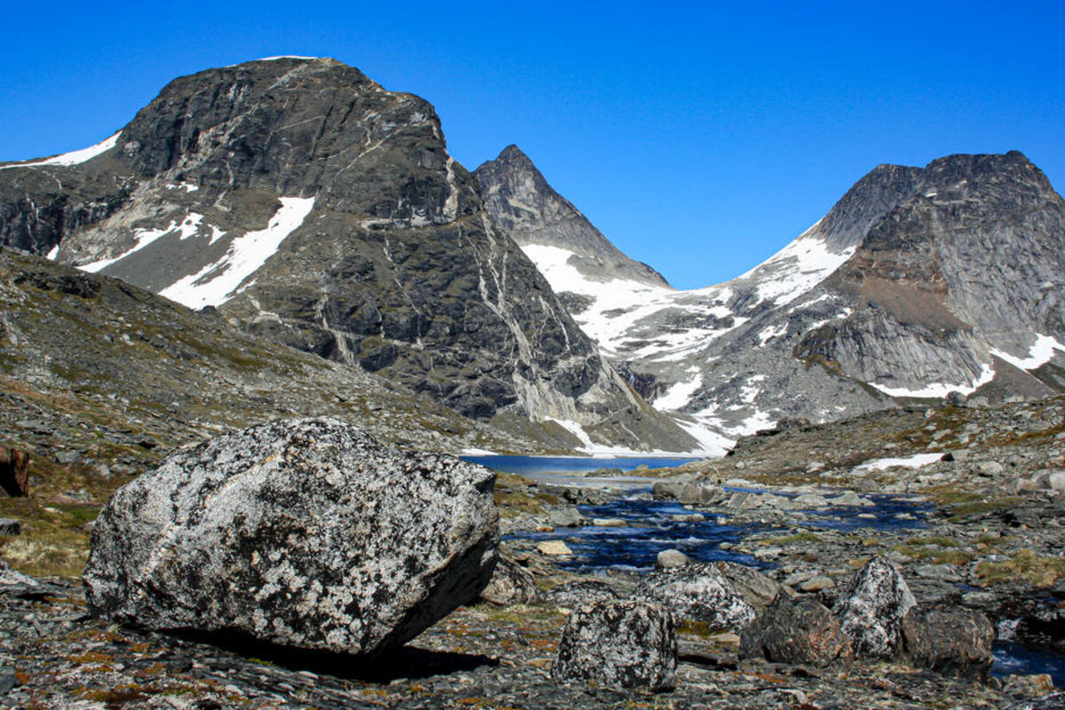
Report Type | Regulatory Standard | Effective Date
Technical Report Summary (TRS) | Item 1300 of Regulation S-K (U.S. SEC) | 26 April 2026

Qualified Person | Portfolio Area
Malcolm Castle, MAusIMM (CP Geo) Agricola Mining Consultants Pty Ltd | 160 km² (Three Exclusive Exploration Licences Grant Date: 20 April 2026)

IMPORTANT NOTICE: This Technical Report Summary is prepared in accordance with Item 1300 of Regulation S-K. The Properties are classified as exploration-stage under S-K 1300. No Mineral Resources or Mineral Reserves have been defined. Exploration potential is conceptual in nature. There is no certainty that further exploration will result in the definition of Mineral Resources or Mineral Reserves.

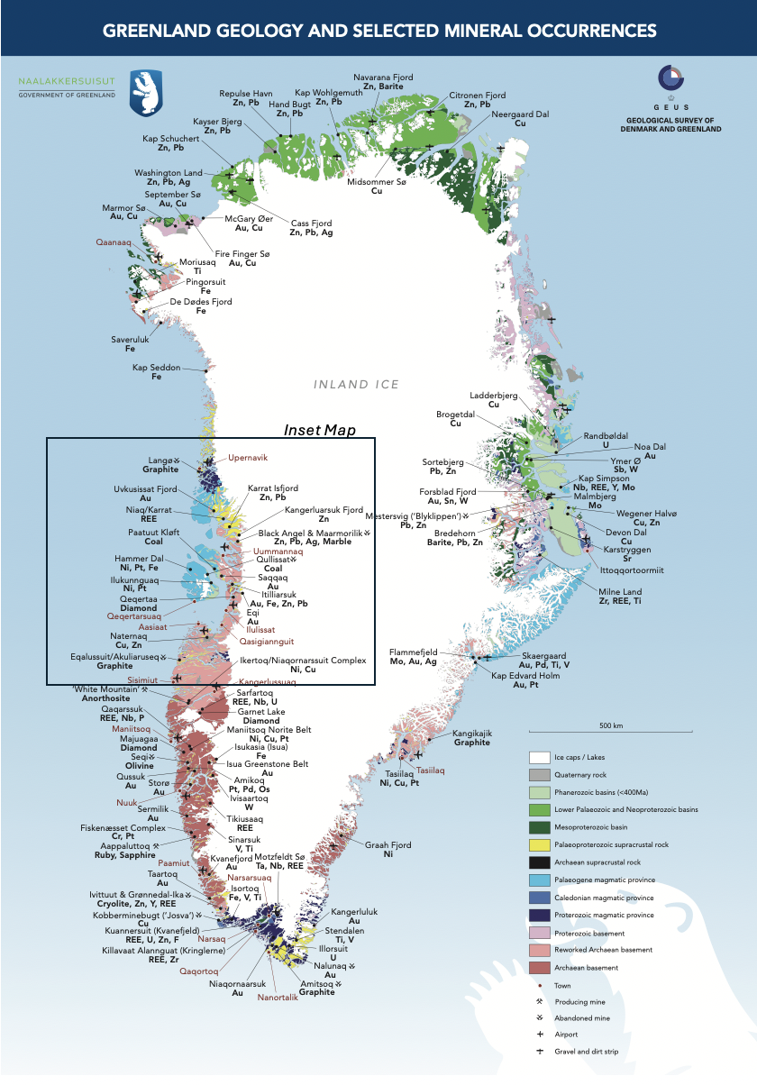
Mineral Deposits in Greenland and the location of the West Greenland Gold projects

ITEM 1. EXECUTIVE SUMMARY

1.1 Introduction
This Technical Report Summary ("TRS" or "Report") has been prepared in accordance with the requirements of Subpart 1300 of Regulation S-K ("S-K 1300") promulgated by the United States Securities and Exchange Commission ("SEC"). The Report supports the disclosure of exploration results for the West Greenland Gold Portfolio (the "Portfolio"), comprising three early-stage gold prospects — Eqi, Attu, and Itilliarsuk — situated within the Ilulissat District of central West Greenland.
The three Exclusive Exploration Licences comprising the Portfolio were formally granted with an effective date of 20 April 2026, confirming the Company's exclusive exploration rights across 160 km² of Archean supracrustal terrane in central West Greenland. The Qualified Person has determined that all Properties are in the exploration stage as defined under S-K 1300. No Mineral Resources or Mineral Reserves have been estimated for any of the Properties.
Notwithstanding this, the Portfolio presents a compelling and differentiated opportunity in one of the world's most geologically underexplored but highly prospective Arctic gold districts. Recent academic research published by Marshall & Schønwandt (1999) on the Archaean sill complex of Arveprinsen Ejland has significantly refined the understanding of the tectonic and magmatic framework of the region, providing important new geological context for the mineralisation models at Eqi, Attu, and Itilliarsuk.

1.2 Why West Greenland Gold is Compelling
The Portfolio sits within the North Atlantic Craton — an Archean geological province globally recognized for hosting world-class gold systems. The geological fundamentals across all three prospects are structurally and geochemically analogous to some of the most productive gold camps in the world, including the Abitibi Greenstone Belt in Canada and the Homestake BIF-hosted system in the United States. Published academic research (Knudsen et al. 1988; Marshall & Schønwandt 1999) confirms the Arveprinsen Ejland supracrustal sequence as a genuine Archaean arc-volcanic association with high-magnesium tholeiitic and basaltic komatiitic affinities — a geological setting globally recognised as one of the most prospective for orogenic gold formation.
- Three distinct, geologically differentiated gold prospects across 160 km² of exclusive exploration licence ground (licences granted 20 April 2026)
- High-grade surface gold documented across all three prospects (peak result: 60 g/t Au at Eqi)
- Drill confirmation of gold at depth at both Eqi West (12 g/t Au over 3.8 m) and Itilliarsuk (0.82 g/t Au over 3.1 m)
- Structurally coherent orogenic and BIF-hosted mineralisation models with precedent in the world's largest gold deposits
- Abundant massive and disseminated sulphide mineralisations documented within the supracrustal sequence (Knudsen et al. 1988) — a critical indicator of hydrothermal system activity
- Archaean sill complex of komatiitic to tholeiitic affinity confirmed at Arveprinsen Ejland (Marshall & Schønwandt 1999), interpreted as ensialic arc-related — directly supporting the orogenic gold framework at Eqi and Attu
- Stable, mining-friendly jurisdiction — Greenland operates under Danish and EU-aligned regulatory frameworks
- Significant first-mover advantage in an underexplored Arctic gold district
- Independent Fair Market Valuation of USD 8.6M – USD 13.0M using VALMIN-compliant methodology

1.3 Property Overview
Prospect | Area (km²) | Licence Status | Gold Model | Priority
Eqi | ~50 | Granted 20 April 2026 | Hydrothermal orogenic greenstone-hosted | 1 — Highest
Attu | ~40 | Granted 20 April 2026 | Orogenic shear-corridor gold | 2
Itilliarsuk | ~70 | Granted 20 April 2026 | BIF-hosted / sulphide-shear gold | 3

Location of Eqi, Attu and Itilliarsuk Project Areas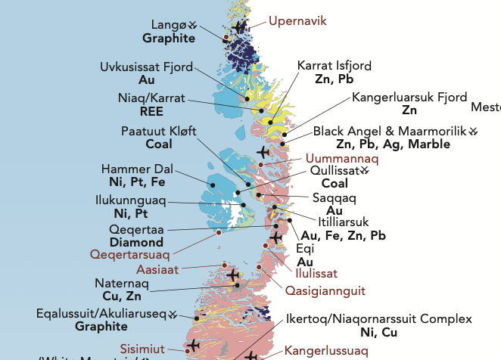
Location of Eqi, Attu and Itilliarsuk Project Areas

1.4 Summary of Exploration Results
1.4.1 Eqi Prospect — Flagship Asset
Eqi is the most comprehensively documented and highest-priority prospect. It features a documented alteration footprint 50–200 m in width and multiple confirmed high-grade gold occurrences from surface and subsurface programs spanning four decades. The breccia zones at Eqi carry sulphide mineral assemblages — including ankerite, chalcopyrite, and chlorite in a matrix-supported breccia (sample 341442 and 341445 from Knudsen et al. 1988) — geochemically consistent with the sill complex environment described by Marshall & Schønwandt (1999).

Sample Type | Gold Grade | Context
Grab sample | 60 g/t Au | Pyrite-bearing quartz vein, Eqi East
Surface grab | 22 g/t Au | Eqi West Cu-Au breccia zone
Rock sample | 5.85 g/t Au | Carbonate-altered host rock
Chip sample | 6 g/t Au over 15 m | Historical program, Eqi East (1991)
Drill intersection | 12 g/t Au over 3.8 m, 1.3% Cu | Eqi West — confirms depth continuity
Chip sample line | 1–2 g/t Au over >10 m | Broad anomalism confirmed, 2009–2010

1.4.2 Attu Prospect — Multi-Kilometre Structural Corridor
Attu represents a major structurally-controlled orogenic gold target hosted in a 100–330 m wide mylonite corridor. The Nagssugtoqidian orogen hosting the Attu shear corridor is characterised by ESE-WNW trending structural fabric and a history of ductile shearing under amphibolite-facies conditions, consistent with regional structural descriptions in Knudsen et al. (1988). All documented gold values exceed 1 g/t Au.
Sample Type | Gold Grade | Context
Surface samples | 2–8 g/t Au | Silicified mylonite within shear corridor
GEUS-verified samples | >1,000 ppb Au (>1 g/t) | Consistent across all published summaries
1.4.3 Itilliarsuk Prospect — Archean BIF-Hosted Gold Target
Itilliarsuk is a conceptual but geologically credible BIF-hosted gold system. The best surface result (9 g/t Au over 1.7 m) is significant. A 1998 reconnaissance drill program confirmed mineralised sulphide horizons at depth. Published chemical analyses from the Arveprinsen supracrustal sequence (Marshall & Schønwandt 1999) confirm the presence of massive sulphide occurrences with pyrite-chalcopyrite, pyrrhotite-sphalerite assemblages and high base metal tenors — directly analogous to the sulphide lithologies hosting gold at Itilliarsuk.
Sample Type | Gold Grade | Context
Surface channel | 9 g/t Au over 1.7 m | Quartz-sericite shear zone (best historical result)
Drill intersection | 0.82 g/t Au over 3.1 m | 1998 programme, 6 holes, 1,482 m
Quartz-sulphide veins | Traceable >800 m | Along-strike continuity documented

1.5 Proposed Exploration Program
Phase | Activities | Estimated Cost (USD) | Timeline
Phase 1 | Target Definition: structural mapping, systematic channel sampling, geochemical grids, geophysics across all three Prospects | 1.05M – 1.95M | Months 3–12
Phase 2 | Scout Diamond Drilling: 1,500–3,000 m per Prospect, oriented core, multi-element geochemistry, structural interpretation | 5.0M – 9.5M | Months 15–30
Total | — | 6.05M – 11.45M | 24–30 months

1.7 Key Risks
- No Mineral Resources or Mineral Reserves have been defined across the Portfolio
- Gold grade continuity and mineable widths remain unproven
- Historical datasets predate modern QA/QC protocols
- Arctic logistical constraints (seasonal access, helicopter dependency, short field season)
- Commodity price volatility and exploration funding risk
- Environmental and permitting requirements under Greenland regulatory framework

Qualified Person Conclusion: Eqi is the most technically robust prospect with a demonstrated hydrothermal gold system and local high-grade intersections. Attu offers compelling structural scale within the Nagssugtoqidian orogen. Itilliarsuk is conceptually strong and under-explored within a proven sulphide-bearing supracrustal sequence. All three Prospects warrant systematic, phased exploration investment. Licence grant date of 20 April 2026 marks the commencement of the Company's exclusive exploration period.

ITEM 2. INTRODUCTION

2.1 Purpose of the Report
This Technical Report Summary has been prepared in accordance with Item 1302 of Regulation S-K to support the disclosure of exploration results for the West Greenland Gold Portfolio. The Properties are classified as exploration-stage under S-K 1300, and no Mineral Resources or Mineral Reserves have been estimated. The three Exclusive Exploration Licences were formally granted with an effective date of 20 April 2026.
The Report purpose is to: summarise all known geology for each Property; present documented historical exploration results; provide geological context for mineralisation styles incorporating recent academic research; assess conceptual exploration potential; describe planned exploration programs; identify material risks and uncertainties; and provide sufficient information for public disclosure in accordance with S-K 1300.

2.2 Qualified Person
The scientific and technical information in this TRS has been reviewed and approved by Malcolm Castle, MAusIMM (CP Geo), who is a Qualified Person as defined in Item 1300 of Regulation S-K. Malcolm Castle is independent of the Company and has more than 50 years of experience in the exploration and evaluation of gold deposits, including 30 years of specific experience with Archean greenstone-hosted and BIF-hosted gold systems.
The Qualified Person has verified the data disclosed, including sampling, analytical, and test data underlying the information or opinions contained in this Technical Report Summary, to the extent reasonably practicable. No material issues affecting the reliability of the data have been identified.

2.3 Scope and Limitations
The scope encompasses property descriptions, regional and local geology (incorporating published academic literature through 1999), historical exploration results, geological interpretation and conceptual models, recommended exploration plans, data verification, risks and uncertainties, and supporting references. The principal limitations are: historical sampling predates modern QA/QC protocols; original sample certificates for certain datasets are unavailable; drill databases for Attu and Itilliarsuk are incomplete; and the Qualified Person has not conducted site visits.
This report does not declare Mineral Resources or Mineral Reserves, does not present a Preliminary Economic Assessment, and does not include production forecasts or economic analyses such as NPV or IRR.

ITEM 3. PROPERTY DESCRIPTIONS AND TENURE

3.1 Tenement Summary
The three Exclusive Exploration Licences comprising the West Greenland Gold Portfolio were formally granted with an effective date of 20 April 2026. This confirmed the Company's exclusive rights to explore for minerals across 160 km² of Archean supracrustal and Proterozoic terrane in central West Greenland.
Tenement | Area (km²) | Licence Type | Licence Grant Date | Location
Eqi | ~50 | Exclusive Exploration Licence | 20 April 2026 | Central West Greenland, Ilulissat District
Attu | ~40 | Exclusive Exploration Licence | 20 April 2026 | Nagssugtoqidian orogen, Central West Greenland
Itilliarsuk | ~70 | Exclusive Exploration Licence | 20 April 2026 | South coast of Nuussuaq, Central West Greenland
Total Portfolio | 160 | — | — | —

Greenland exploration licences are exclusive for mineral exploration and are subject to annual work commitments and expenditures under Greenland Mineral Licence regulations. The licence system is transparent, well-established, and operated under Danish and Greenlandic legal frameworks, providing a high degree of tenure security.

3.2 Jurisdiction and Regulatory Framework
Greenland operates under the Mineral Resources Act (2009, as amended), administered by the Greenlandic Government (Naalakkersuisut). The legal framework provides clearly defined licence periods and renewal rights; transparent annual reporting obligations; a stable royalty and taxation framework consistent with international standards; and alignment with EU regulatory norms given Greenland's status as an autonomous territory within the Kingdom of Denmark.
The Qualified Person notes the jurisdictional risk for Greenland is low relative to many frontier Arctic exploration regions. This is reflected in the Geofactor scoring (Jurisdictional Risk: 0.75/1.00 across all Prospects).

ITEM 4. GEOLOGICAL SETTING
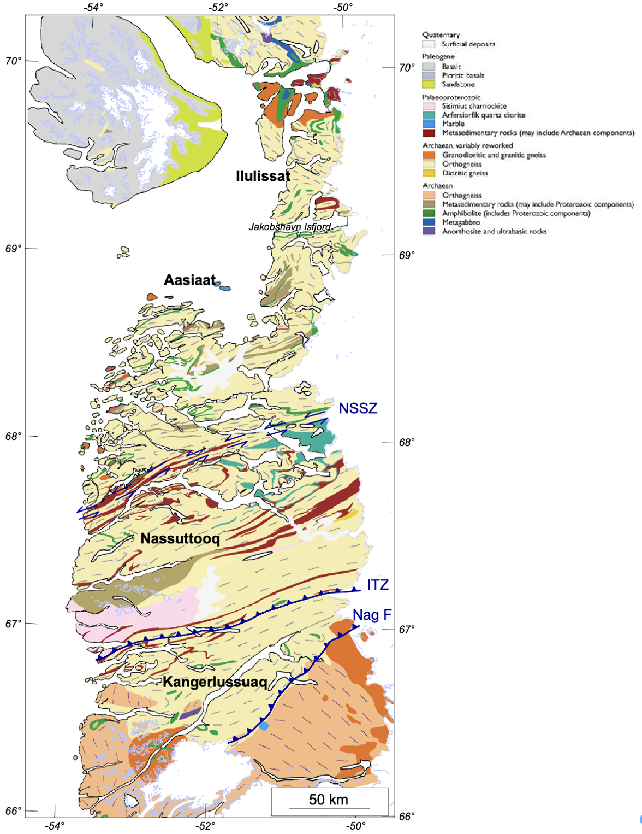
Central West Greenland Geological Setting

4.1 Regional Geological Framework
The West Greenland Gold Portfolio is located within Archean to Paleoproterozoic terranes of the North Atlantic Craton in the Ilulissat region (also known as the Disko Bugt area) of central West Greenland. The rocks of Arveprinsen Ejland, Disko Bugt, were first divided by Escher & Burri (1967) into an infrastructure of Jacobshavn gneiss and Atâ granite, and a suprastructure termed the 'Anap nunâ Group.' Subsequent isotopic studies by Kalsbeek et al. (1988) demonstrated that at least for north-eastern Arveprinsen Ejland, the supracrustal rocks are Archaean and distinct from the Proterozoic supracrustal sequence that occurs east of Arveprinsen Ejland.
This geological province is characterised by Archean supracrustal sequences (2.8–2.85 Ga); bimodal volcanic assemblages (mafic and felsic); Banded Iron Formations (BIF) of both oxide and sulphide facies; regional thrusting and multi-phase folding; major shear zone development and structural corridors; and multiple deformation events creating complex structural architecture.
Critically, such Archean geological environments are globally recognised as highly prospective for both orogenic gold and BIF-hosted gold systems. The Ilulissat area hosts the Arveprinsen-Eqi supracrustal belt, Nagssugtoqidian orogen, and Nuussuaq metasedimentary sequences — all proven gold-hosting geological environments at the regional scale.

4.2 The Arveprinsen Supracrustal Sequence: Academic Framework
Published research by Knudsen, Appel, Hageskov and Skjernaa (1988) and Marshall & Schønwandt (1999) provides the definitive scientific framework for the supracrustal rocks of the Eqi-Arveprinsen area. These publications form an essential part of the geological basis for the mineralisation models across the Portfolio.
4.2.1 Stratigraphy of the Supracrustal Sequence
The Archaean supracrustal rocks of north-eastern Arveprinsen Ejland comprise a metamorphosed sequence of massive to pillowed basaltic flows and mafic tuffs, with subordinate felsic volcanic rocks, overlain by and gradationally into an epiclastic sedimentary sequence, also with felsic volcanic rocks (Marshall & Schønwandt 1999). The metavolcanic-metasedimentary preserved succession (excluding the sill complex) consists of:
- A lower unit comprising 2,500–3,000 m of mafic flows and tuffs
- An upper unit comprising 500–750 m of feldspathic, siliciclastic and pelitic epiclastic metasedimentary rocks, with developments of disseminated and massive base metal sulphide
The sill complex effectively swells the total thickness of the supracrustal section to between 5,000 and 6,000 m, constituting nearly 50% of the stratigraphic column (Marshall & Schønwandt 1999). This remarkable proportion of intrusive material within the supracrustal pile is directly relevant to the hydrothermal gold mineralisation models at Eqi: the multiple intrusive contacts created by at least eight component sills provided the thermal and structural controls necessary for focused hydrothermal fluid circulation.
4.2.2 The Archaean Sill Complex — Significance for Gold
Marshall & Schønwandt (1999) identified and characterised a mafic to ultramafic sill complex on Arveprinsen Ejland with a strike-length of 7,500 m and a cumulative preserved thickness of 2,000–2,500 m. Several key characteristics of this sill complex are directly relevant to the gold endowment of the Portfolio:
- Chilled and locally peperitic contacts between component sills and the inter-sill metasedimentary septa — indicating emplacement into water-saturated sediment (wet, poorly lithified) at shallow sub-seafloor depths, creating ideal conditions for hydrothermal circulation
- The sill complex was progressively emplaced as an upward-younging sequence of component sills beneath 2 to 2.5 km of seawater — consistent with a subvolcanic environment analogous to modern seafloor hydrothermal systems
- At least eight individual sills have been mapped, each differing from immediately overlying and underlying sills in terms of gross appearance and degree of internal variation
- Chilled margins were recorded at upper, lower, and lateral contacts, confirming rapid intrusion into cool, poorly-lithified sediment
- The sub-alkalic sill complex and mafic lavas and tuffs are high-magnesium tholeiites and basaltic komatiites — magma types globally associated with Archaean volcanic belts prospective for orogenic gold
The emplacement mechanism involved dilation when magmatic pressure exceeded the effective overburden pressure plus the vertical tensile strength of the host materials (Marshall & Schønwandt 1999). This repeated intrusive episode created a series of contact metamorphic aureoles and fluid pathways that, during later deformation, would have served as structural conduits for gold-bearing hydrothermal fluids.
4.2.3 Tectonomagmatic Setting — Arc-Volcanic Association
Tectonomagmatic discrimination plots presented by Marshall & Schønwandt (1999) suggest an ensialic arc-related setting for the sill complex and the mafic and felsic volcanic rocks. Specifically:
- The sill complex and basaltic rocks plot as island-arc tholeiites (with some overlap into calc-alkaline basalts) on the TiO₂–MnO–P₂O₅ diagram of Mullen (1983)
- They occupy the fields of island-arc basalts on diagrams of Zr/Y versus Zr (Pearce & Norry 1989) and Ti/Zr versus Zr/Y (Condie 1990)
- The felsic volcanic rocks are calc-alkaline rhyolites and dacites — consistent with the upper, silicic portion of an arc magmatic system
- Chondrite- and MORB-normalised spider diagrams affirm close similarity between the mafic volcanic rocks and the sill complex, confirming they are co-magmatic
This arc-volcanic tectonic setting is a globally recognised environment for the formation of orogenic gold systems. The association of high-Mg tholeiites, calc-alkaline felsics, and a subvolcanic sill complex is characteristic of Archaean volcanic belts that host world-class gold deposits in the Abitibi Belt, the Yilgarn Craton, and the Superior Province of Canada.
4.2.4 Sulphide Mineralisation in the Supracrustal Sequence
Knudsen et al. (1988) documented three distinct types of sulphide mineralisation within the Eqi-Arveprinsen supracrustal sequence, all of which are directly relevant to the gold models at the Portfolio properties:
Sulphide Type | Location | Key Mineral Assemblage | Relevance to Gold
Iron-formation | Central and southern Eqe area; three horizons | Schistose magnetite-rich rock with phyllites and quartz-sericite schist; garnet-quartz-magnetite in amphibolite facies | BIF-hosted sulphide system; direct analogue to Itilliarsuk
Disseminated sulphides | All parts of supracrustal region | Pyrite (up to 10 modal%); quartzite, limestone/marble, carbonate-graphitic schists, chlorite schist, pillow lava, altered metadolerite | Indicates pervasive hydrothermal activity; precursor to focused gold mineralisation
Massive sulphides | Arveprinsen Ejland; largest at 'Anderson Showing' | Pyrite-chalcopyrite with pyrrhotite, sphalerite, galena; pyrrhotite-chalcopyrite-sphalerite with amphibole | High base metal tenors confirm robust hydrothermal system; Cu-Au breccia at Eqi West is analogous

Chemical analysis of sulphide-bearing grab samples from the supracrustal sequence (Knudsen et al. 1988, Table 2) yielded significant values including 12.30 g/t Au (sample 341489, clast-supported breccia with carbonate and chalcopyrite veins), 13.10% Cu and 9,900 ppm Zn (sample 341510, massive pyrite-chalcopyrite), and 55,900 ppm Zn (sample 341511, massive pyrrhotite-sphalerite-amphibole). These values confirm a vigorous base metal hydrothermal system capable of concentrating gold in structurally favourable positions.
4.2.5 Breccia Zones — Key Structural Controls on Gold
East or north-east dipping breccia zones, 0.5 to 3 m wide, are present mainly in the metasediments west of the iron-formation but are also found in chlorite schists (Knudsen et al. 1988). These breccia zones are sub-concordant and matrix- to clast-supported with phyllite and schist clasts in a carbonate, chlorite, or quartz-rich matrix. The breccia contains sulphides including chalcopyrite, pyrrhotite, sphalerite, and galena.
At Eqi, sulphide-rich breccia zones have been followed up to 100 m along strike. At Arveprinsen Ejland, a 1 to 5 m wide breccia zone has been followed for approximately 5 km. The largest breccia occurrence (location 3 on the geological map) is locally rich in sulphides, mainly pyrite, but locally massive chalcopyrite and sphalerite — directly analogous to the Eqi West Cu-Au breccia zone that yielded the confirmed drill intersection of 12 g/t Au over 3.8 m and 1.3% Cu.
4.2.6 Deformation History and Structural Framework
Knudsen et al. (1988) described a systematic increase in deformational imprint from east to west across the supracrustal belt, from almost undeformed pillow lavas near the Inland Ice, through rocks with a well-developed schistosity, to tightly to isoclinally folded foliation refolded by kink folds in the westernmost part. This structural pattern has direct implications for gold targeting:
- The highest-grade zones at Eqi are structurally controlled by N-S shear zones and late brittle overprinting — consistent with the youngest deformation episode
- Carbonate veins in the axial plane of kink folds in the westernmost supracrustals are interpreted as syn-deformational and represent fluid pathways during the latest deformation episode
- The Pakitsoq shear zone south of the Atâ granite complex is characterised by an ESE-WNW trending structural grain from ductile shearing under amphibolite-facies conditions followed by brittle ESE-WNW trending faults — the structural environment hosting the Attu gold corridor

4.3 Metamorphic Framework
The major part of the Eqe area is in greenschist facies, but in the western part the supracrustals have been metamorphosed under amphibolite-facies conditions (Knudsen et al. 1988). The boundary between greenschist and amphibolite facies is discordant to the layering in the supracrustals on Arveprinsen Ejland, and there is a general increase in metamorphic grade towards the contact to the orthogneiss. This metamorphic gradient has two important implications for gold exploration:
- Gold-bearing fluid flow was likely focused along the metamorphic gradient, which represents a zone of rheological contrast and enhanced permeability
- The greenschist-amphibolite transition is a known gold-focussing mechanism in Archean terranes globally, equivalent to the metamorphic gold traps identified in the Abitibi Belt
The supracrustal rocks on the Arveprinsen supracrustal belt have undergone at least one phase (but probably two phases) of regional metamorphism. The resulting greenschist and amphibolite facies assemblages define a south-closing form within the Atâ granite (Knudsen et al. 1988). The metamorphic facies boundary is approximately parallel to primary layering on the west of the structure but is discordant on the east side where the contact truncates the layering.

4.4 Why This Setting Matters for Investors
The North Atlantic Craton is geologically analogous to two of the world's most gold-prolific Archean provinces. Published academic research (Marshall & Schønwandt 1999) now confirms that the Arveprinsen supracrustal sequence represents a genuine ensialic arc-volcanic association — precisely the tectonic setting that hosts the world's largest Archean gold deposits:
- The Abitibi Greenstone Belt (Canada) — the world's largest Archean gold province, hosting >70 million ounces of historical production from analogous arc-related orogenic systems
- The Superior Province shear-zone corridors — host to world-class orogenic gold deposits including Kirkland Lake, Hemlo, and Red Lake
- The Homestake/Musselwhite type BIF-hosted gold systems — some of the largest gold mines in North American history

The geological ingredients for significant Archean gold systems are present across the West Greenland Gold Portfolio. The North Atlantic Craton has remained relatively underexplored relative to its Canadian and West Australian counterparts, representing a genuine first-mover opportunity. The confirmation by Marshall & Schønwandt (1999) of an ensialic arc-volcanic tectonomagmatic setting for the Arveprinsen supracrustal sequence substantially elevates the geological credibility of the Portfolio's orogenic gold models.

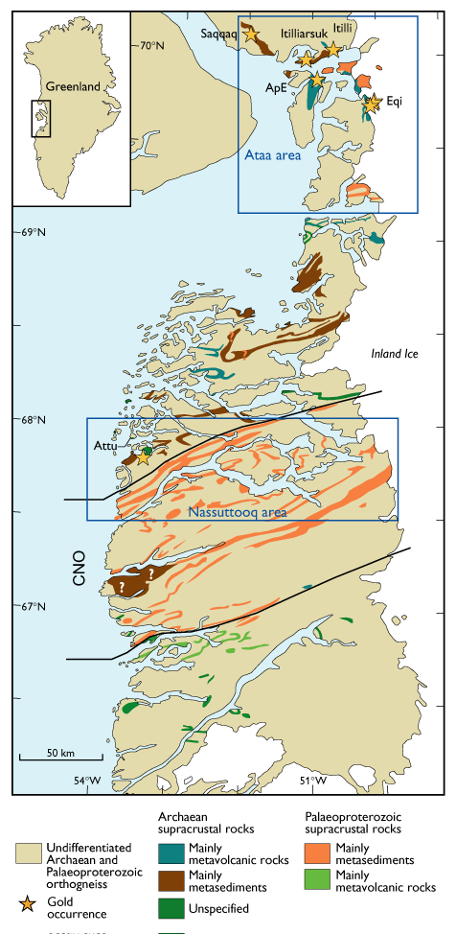
Gold deposits in the Central West Greenland Region
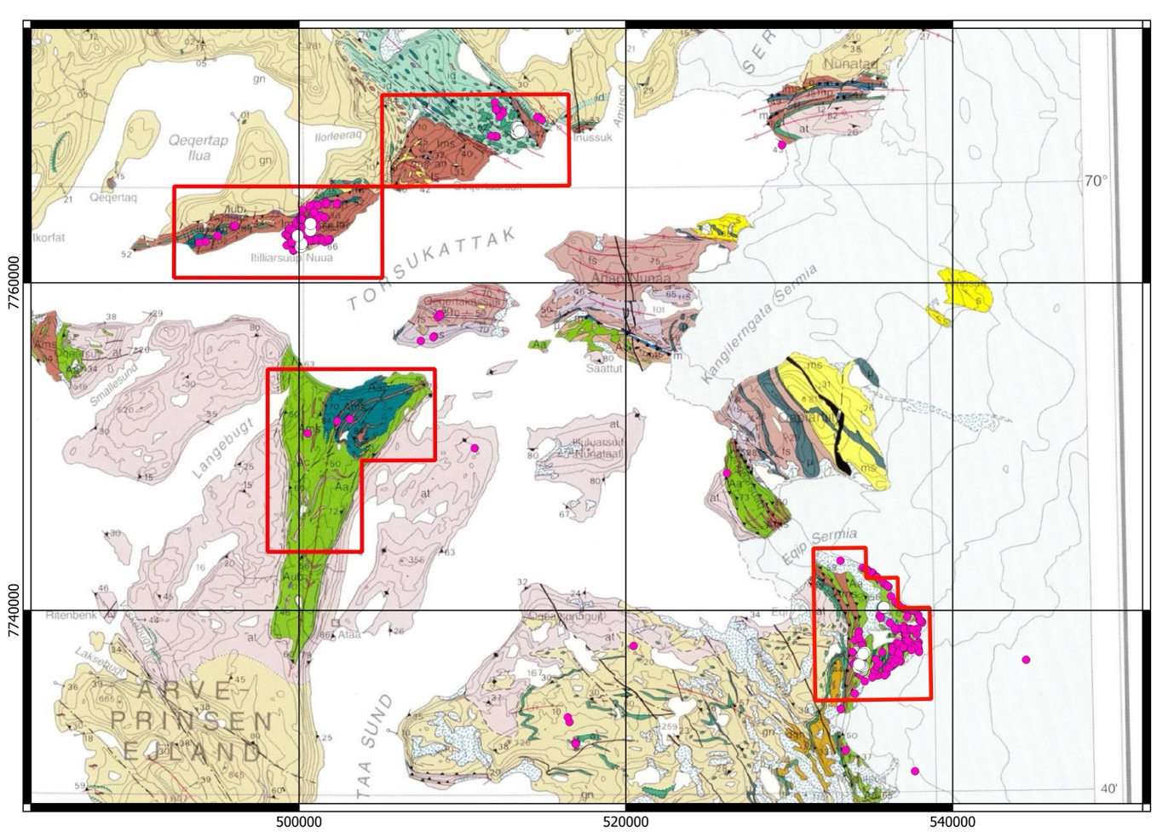
Location of Eqi, south east, and Itilliarsuk (north west – three blocks

4.5 Local Geology — Eqi Prospect
Eqi is hosted within the 2.8 Ga Arveprinsen-Eqi supracrustal belt, comprising metamorphosed mafic and felsic volcanic rocks consistent with an Archaean volcanic island arc setting as confirmed by Marshall & Schønwandt (1999). The supracrustal rocks in this area consist of igneous and sedimentary rocks that have undergone greenschist to amphibolite facies metamorphism (Knudsen et al. 1988). A wide range of metamorphosed igneous rock types are represented, ranging from ultramafic rocks to intermediate and acid metavolcanics. The metasediments consist of a variety of siliciclastic rocks, as well as marble, chert and iron-formation. At least two generations of basic intrusive rocks are found in the supracrustals.
Three distinct mineralisation types are present at Eqi:
- Type 1: Syngenetic gold associated with semi-massive pyrite horizons up to 20 cm thick, with carbonate-sericite alteration and pervasive fuchsitisation
- Type 2: Hydrothermal vein-hosted gold (dominant) — occurring in pyrite-bearing quartz veins, quartz-ankerite vein networks, and shear-zone hosted veins (this style produced the 60 g/t Au grab sample)
- Type 3: Epigenetic Cu-Au breccia-hosted gold at Eqi West (produced: 22 g/t Au grab sample and 12 g/t Au over 3.8 m in drilling) — directly analogous to the chalcopyrite-pyrite breccia zones documented throughout the supracrustal sequence by Knudsen et al. (1988)
The alteration footprint at Eqi is 50–200 m wide. Key alteration minerals include carbonatisation (ankerite, dolomite, calcite), sericitisation, chloritisation, fuchsitisation, silicification, and pyritisation — precisely the alteration assemblage associated with the silicified breccia zones containing chalcopyrite veins documented by Knudsen et al. (1988).
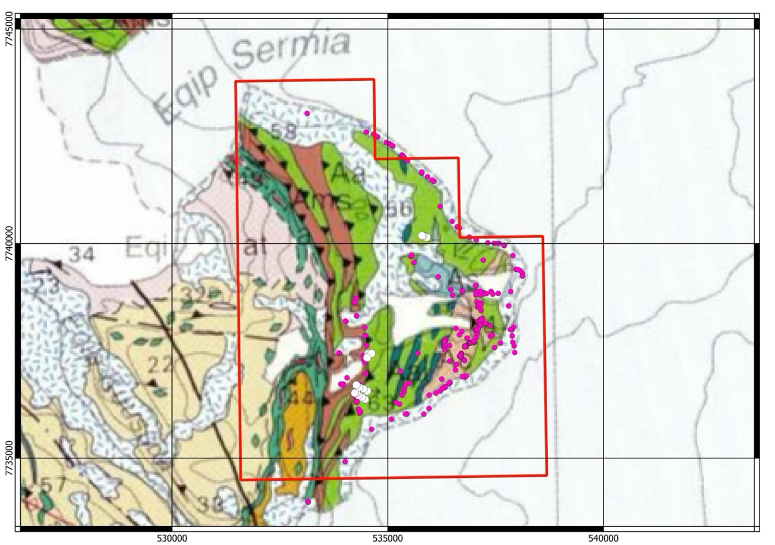
Detailed geology of the Eqi Project

4.6 Local Geology — Attu Prospect
Attu is hosted within the Nagssugtoqidian orogen, occurring in granulite-facies orthogneiss and amphibolite. The Pakitsoq shear zone area south of the Atâ granite complex is considered by Knudsen et al. (1988) to be the continuation of a Canadian fault zone along which a sinistral displacement of several hundred kilometres is suggested. The defining structural feature is a major mylonite corridor with the following geometry:
Parameter | Value
Corridor Width | 100–330 metres
Strike Direction | ~75° (ENE-WSW)
Dip | 60–70° west
Known Strike Length | Several kilometres
Gold Grades | 2–8 g/t Au (silicified mylonite)
Structural Fabric | ESE-WNW trending from ductile shearing under amphibolite-facies conditions (Knudsen et al. 1988)

Three major deformational events are recognised in the Pakitsoq area by Knudsen et al. (1988): an oldest event under amphibolite facies resulting in folding of migmatite structure; an intermediate ductile shearing event under amphibolite facies creating the overall ESE-WNW trending structural grain; and the most recent event resulting in brittle faulting creating ESE-WNW trending subvertical faults with about 50 m wide cataclastite zones. Gold at Attu is restricted to silicified mylonite zones, shear-parallel quartz-sulphide veins, and late brittle deformation overprinting ductile fabrics — consistent with gold emplacement during the transition from ductile to brittle deformation, a well-established gold-focussing mechanism globally.
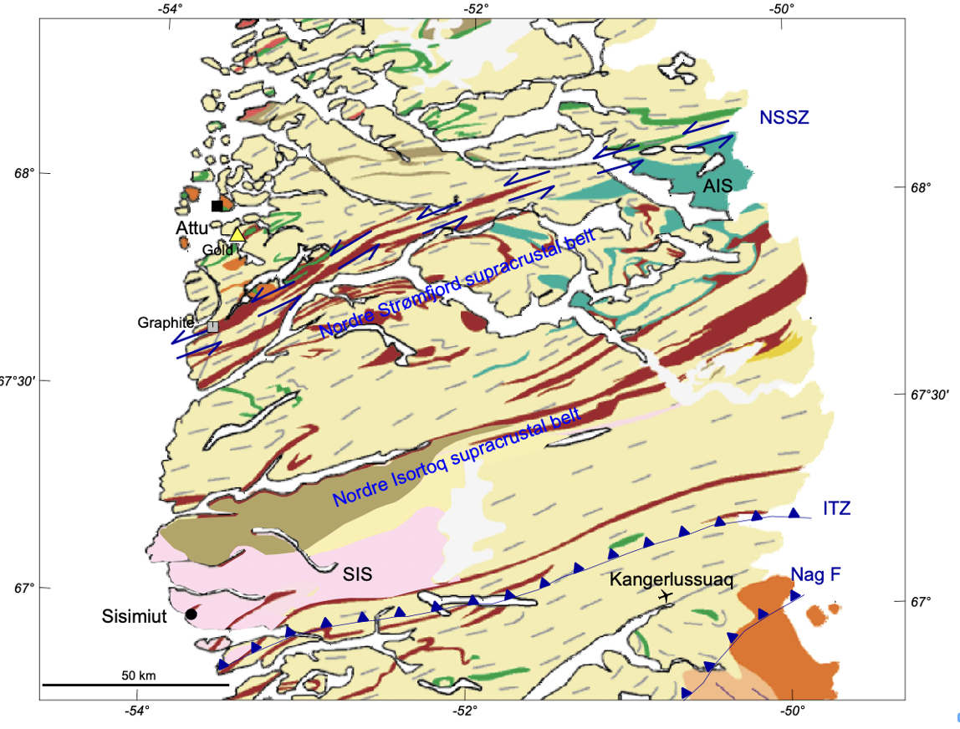
Main features of the geology of the Nassuttooq area

4.7 Local Geology — Itilliarsuk Prospect
Itilliarsuk is hosted within an Archean (~2.85 Ga) metasedimentary sequence on the south coast of Nuussuaq. The iron-formation at the Eqe area — the directly analogous BIF system described by Knudsen et al. (1988) — occurs in three horizons at the lowest part of a metasedimentary sequence, changing along strike from a schistose magnetite-rich rock interlayered with phyllites and quartz-sericite schist in the central part (greenschist facies) to an isoclinally folded, banded garnet-quartz-magnetite rock in the southern part (amphibolite facies). The iron-formation is up to 5 m thick and can be followed 4 km along strike.
Key lithological units at Itilliarsuk include:
- Banded Iron Formation (BIF) — both oxide (magnetite-rich) and sulphide facies (pyrite + pyrrhotite), locally up to 150 m thick
- Sulphidic Mica Schist — dominantly biotite-chlorite schist with disseminated sulphides (~150 m thick)
- Quartz-Sericite Schist — the main host to the highest-grade gold results
- Amphibolite — metavolcanic units hosting shear zones and competency contrasts
Mineralised structures at Itilliarsuk are traceable for 500–800 metres along strike. The geological setting is directly analogous to BIF-hosted gold deposits including Homestake (South Dakota, ~35.4 Moz) and Musselwhite (Ontario), providing a compelling conceptual framework for systematic exploration.
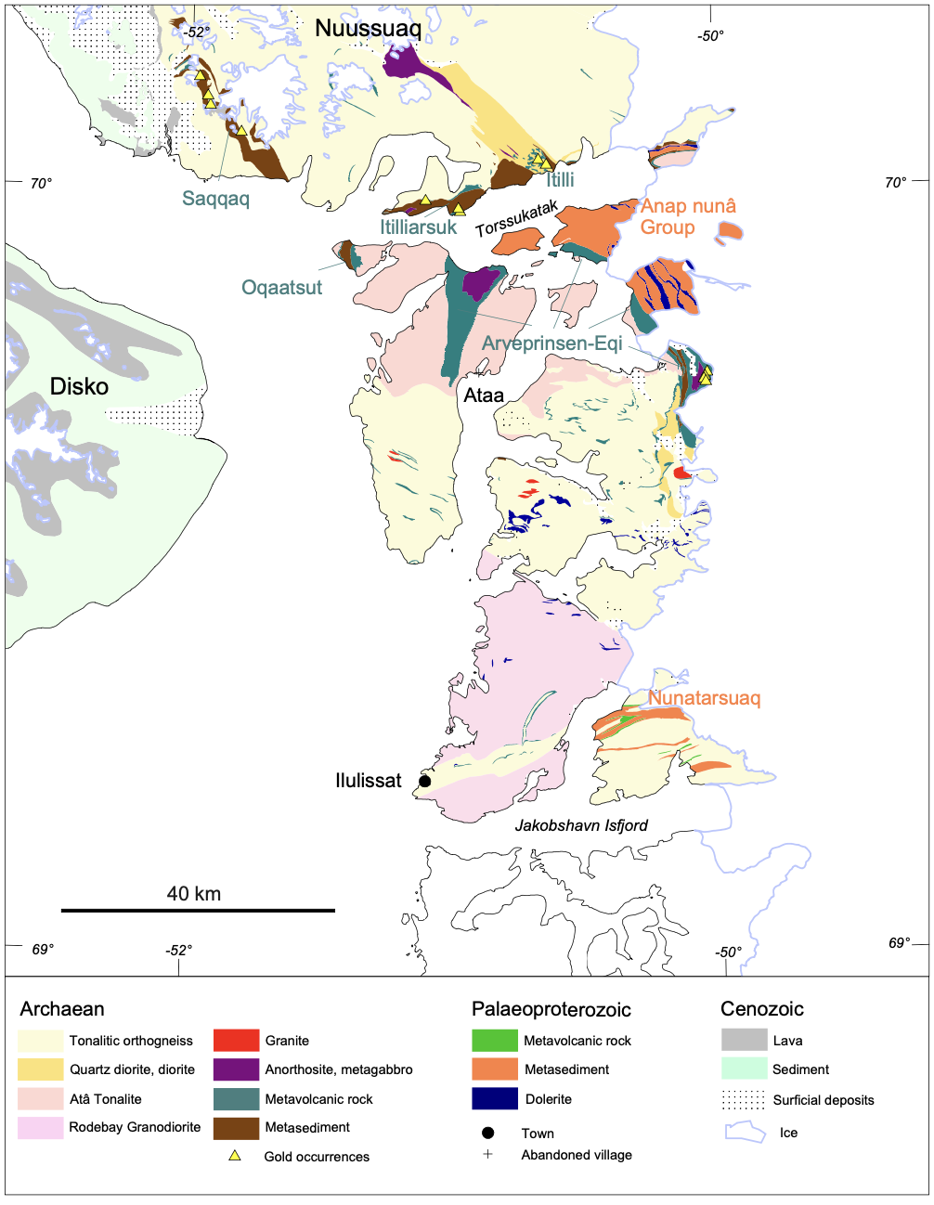
Geology of the Ilulissat area with names of supracrustal belts (Archaean in green,
Paleoproterozoic in orange) and gold occurrences.

ITEMS 5–7. EXPLORATION HISTORY AND RESULTS

5.1 Eqi Prospect — Exploration History
The Eqi Prospect is the most comprehensively documented property in the Portfolio. Historical exploration spans four decades and includes government geological mapping, company-led sampling programs, and limited but confirmatory drilling.
Period | Program | Key Outcomes
1970s–1980s | GGU regional mapping | Identification of supracrustal volcanic belts, alteration, sulphide occurrences, and initial anomalous gold; establishment of the Eqe/Arveprinsen supracrustal geology framework
1988 | Knudsen, Appel, Hageskov & Skjernaa (GGU) | Definitive geological reconnaissance: mapping of all three sulphide types, chemical analysis of grab samples (up to 12.3 g/t Au in breccia), documentation of massive sulphides at 'Anderson Showing', iron-formation characterisation
1988–1991 | Faxe Kalk / Platinova | Detailed mapping; early chip sampling; 6 g/t Au over 15 m at Eqi East; Eqi West drill programme with 12 g/t Au over 3.8 m
1990s | GEUS Investigation | Large sample populations; discovery of up to 60 g/t Au in quartz veins; classification of mineralisation styles
1999 | Marshall & Schønwandt (GEUS Bulletin 181) | Definitive characterisation of the Archaean sill complex; confirmation of arc-volcanic tectonomagmatic setting; petrographic and geochemical framework for the entire supracrustal sequence
2010 | Avannaa Resources | 707 total rock samples (497 channel, 210 grab/chip/vein); structural mapping; geophysical surveys; systematic assessment of Eqi East

5.2 Eqi Prospect — Sub-Target Summary
Target | Characteristics | Significance
Eqi East | Main alteration corridor (50–200 m wide) with late high-grade quartz veins | Primary exploration target; 60 g/t Au grab; broad channel anomalism; greenschist-amphibolite transition zone
Eqi West | Cu-Au breccia zone with limited historical drilling; analogous to massive sulphide at 'Anderson Showing' | Confirmed drill intersection: 12 g/t Au over 3.8 m, 1.3% Cu; chalcopyrite-pyrite breccia directly analogous to Knudsen et al. (1988) sulphide occurrences
Anvil Lake / Trouser Lake | Reinterpreted mafic-ultramafic intrusive contacts; potential sill complex extensions | Secondary targets for future evaluation; sill contacts are gold-focussing structures per Marshall & Schønwandt (1999)
Eqi North | Reconnaissance zone with carbonate alteration and quartz veining | Requires systematic sampling to evaluate

5.3 GEUS Sample Population Statistics — Eqi East
The GEUS (Geological Survey of Denmark and Greenland) dataset provides one of the most robust independent sampling datasets at Eqi, with statistically significant sample populations across all major rock types:
Rock Type | N | Range (ppb Au) | Median (ppb) | Samples >0.5 g/t
Acid Rocks | 62 | 5–1,100 | 9 | 3
Sulphide-Rich Rocks | 8 | 5–172 | 16 | 0
Basic Rocks | 11 | 1–126 | 11 | 0
Carbonate-Altered Rocks | 51 | 5–5,850 | 22 | 6
Quartz-Veined Rocks | 26 | 5–60,000 | 69 | 8

The GEUS data confirm that quartz-veined rocks — the dominant vein style at Eqi — carry the highest gold values and the greatest proportion of high-grade samples. Carbonate-altered rocks form the second most gold-enriched category, consistent with the ankerite-calcite carbonate alteration documented in the breccia zones by Knudsen et al. (1988). This supports the interpretation that structural vein systems are the primary gold-hosting mechanism and that grade distribution is strongly lithologically controlled.
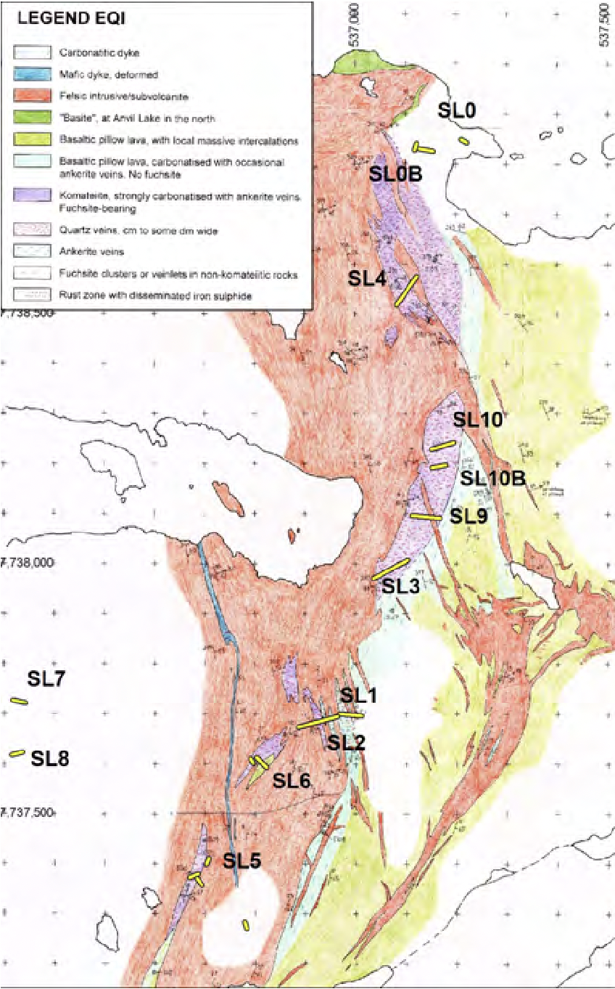
Location of Gold samples - Eqi
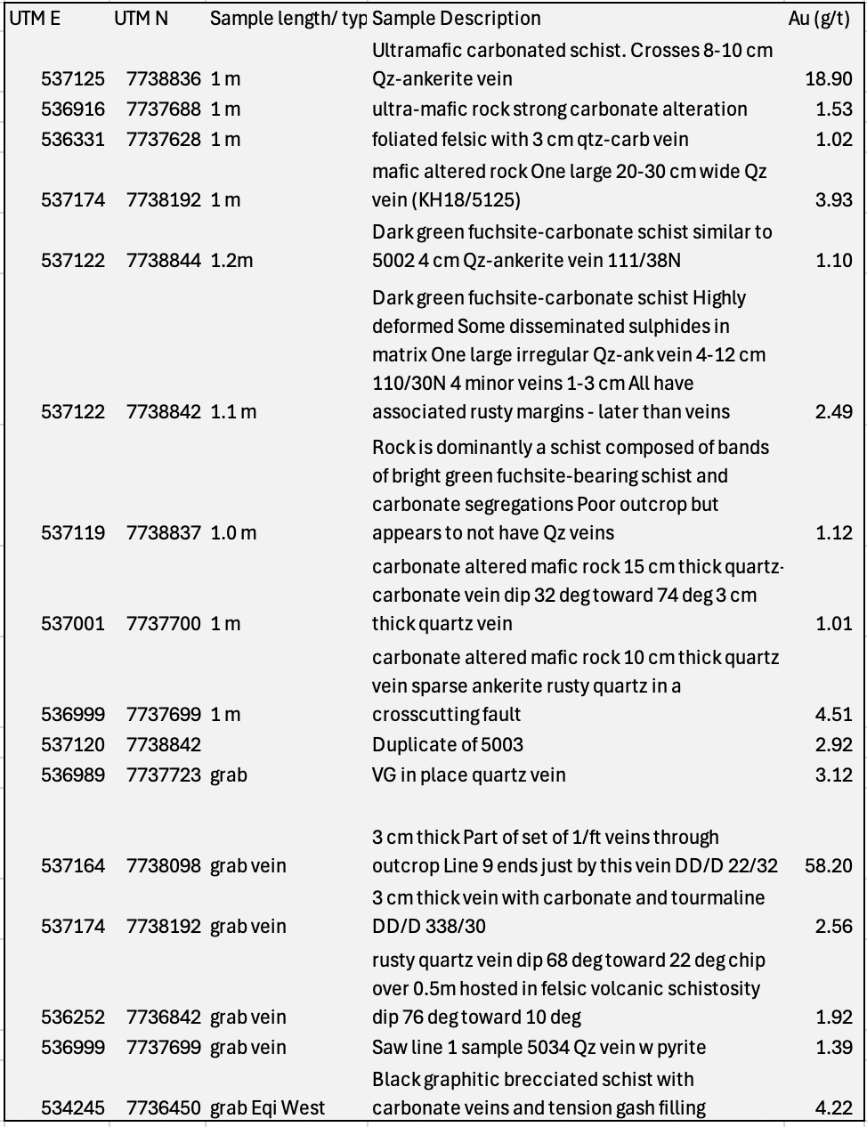
Gold sample Results - Eqi

5.4 Attu Prospect — Exploration History and Results
The Attu Prospect has been documented primarily through GEUS government surveys. The defining characteristic is the reproducibility of gold grades across the mylonite corridor, hosted within the structurally complex Pakitsoq-Nagssugtoqidian shear zone system characterised by Knudsen et al. (1988):
- Surface samples: 2–8 g/t Au from silicified mylonite within the shear corridor
- All documented gold values exceed 1,000 ppb (1 g/t Au) — confirming gold is systemic, not isolated
- Lead isotope studies (Stendal, Frei & Stensgaard, 2006) confirm a structural and age relationship between gold and tectonic events
- Two stream sediment samples returned 12 ppb and 17 ppb Au — indicating catchment-scale gold dispersal
- Three deformational events recognised by Knudsen et al. (1988) in the Pakitsoq area are consistent with multiple gold-focussing episodes during progressive structural evolution

The key strategic insight at Attu is that the entire corridor (100–330 m wide, several km long) has structural architecture — including ESE-WNW ductile shear overprinted by brittle faulting described by Knudsen et al. (1988) — consistent with hosting repeated gold lodes. No systematic drilling has been completed. This represents one of the most compelling undrilled targets in the Portfolio.

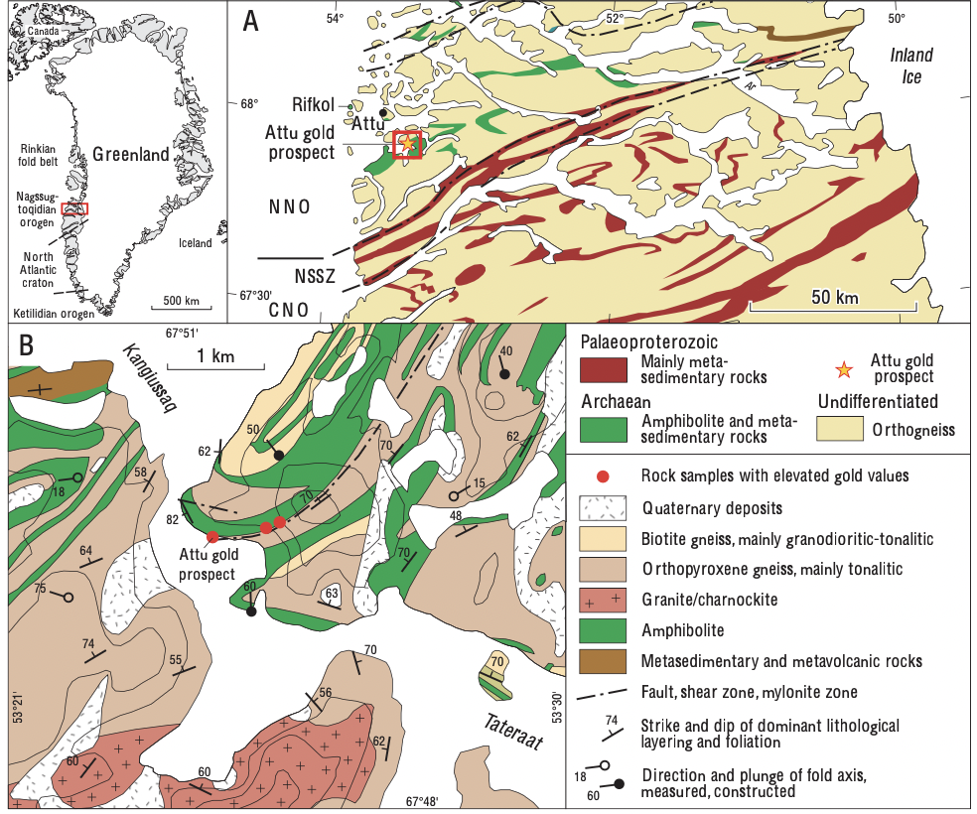

Attu region. A:CNO, central Nagssugtoqidian orogen; NNO, northern Nagssugtoqidian orogen; NSSZ, Nordre Strømfjord shear zone. B: Geological map of the Attu gold prospect area

5.5 Itilliarsuk Prospect — Exploration History and Results
Itilliarsuk has undergone multiple phases of exploration, with the most significant being the 1998 diamond drill programme:
1998 Drilling Programme | Details
Number of Holes | 6 holes (IT9801 to IT9806)
Total Metreage | 1,482 m
Primary Target | Sulphidic schist and BIF contacts
Best Intersection | 0.82 g/t Au over 3.1 m
Key Confirmation | Mineralised sulphide horizons present at depth; structural continuity of shear zones confirmed
Programme Assessment | Acknowledged as premature — structural controls were poorly understood; holes did not target fold hinges or optimal structural positions

The significance of the 1998 drilling is twofold: it confirmed that gold-bearing sulphide systems extend to depth, and it confirmed that structural controls were not adequately targeted. The BIF system at Itilliarsuk is directly analogous to the iron-formation documented by Knudsen et al. (1988) at the Eqe area — comprising three horizons traceable 4 km along strike and changing in character from schistose magnetite-rich rock (greenschist) to isoclinally folded garnet-quartz-magnetite rock (amphibolite facies). Modern geophysical methods (ground magnetics, EM/IP) combined with structural mapping would substantially improve drill targeting at Itilliarsuk.

ITEM 8. COMPARATIVE ANALYSIS OF THE THREE PROSPECTS

8.1 Side-by-Side Technical Comparison
Criterion | Eqi | Attu | Itilliarsuk
Gold Model | Hydrothermal orogenic greenstone | Orogenic shear-corridor | BIF-hosted sulphide-shear
Peak Surface Grade | 60 g/t Au | 2–8 g/t Au | 9 g/t Au over 1.7 m
Best Drill Result | 12 g/t Au / 3.8 m (+ 1.3% Cu) | None drilled | 0.82 g/t Au / 3.1 m
Alteration Width | 50–200 m | 100–330 m corridor | Shear zones 500–800 m strike
Structural Setting | N-S shear zones + late brittle veins | ENE-WSW mylonite corridor + ESE-WNW brittle faults (Knudsen et al. 1988) | BIF fold hinges + shear zones
Sill Complex Proximity | Within/adjacent to sill complex (Marshall & Schønwandt 1999) | Regional (orogen-scale) | Regional; BIF interlayered with metavolcanics
Data Maturity | Most advanced (707 samples + drilling) | Limited (GEUS surface only) | Moderate (surface + 6 drill holes)
Priority Ranking | 1 — Highest | 2 | 3
Geofactor Score | 0.675 | 0.6125 | 0.6625
Kilborn Multiplier | 1.18x | 1.11x | 1.16x

8.2 Structural Preparation Ranking
In terms of structural architecture and potential to host large-scale repeating mineralisation:
- Attu ranks highest structurally — the 100–330 m wide multi-kilometre corridor with documented ESE-WNW ductile shear overprinted by brittle faulting (Knudsen et al. 1988) provides the greatest conceptual scale potential
- Eqi ranks highest for geological confidence — demonstrated high-grade gold with alteration, structural control, partial drill confirmation, and proximity to the Archaean sill complex (Marshall & Schønwandt 1999)
- Itilliarsuk ranks highest for analogue quality — BIF-hosted systems globally are some of the most tonnage-significant gold deposits known; the Knudsen et al. (1988) iron-formation dataset provides the key geological framework

The three-prospect portfolio structure provides natural risk diversification: each Prospect represents a distinct gold model, exploration maturity level, and upside scenario. This is a significant advantage over single-prospect exploration vehicles. Recent academic work confirms the geological pedigree of all three models within the Archaean arc-volcanic framework of the Disko Bugt region.

ITEM 9. ANALOGUE COMPARISON
IMPORTANT DISCLAIMER: Analogues are provided for geological context only and do not imply similar tonnage, grade, continuity, economic viability, or existence of Mineral Resources or Reserves at any of the subject properties.

9.1 Analogue Summary Table
Greenland Prospect | Primary Model | Closest Analogue | Shared Features
Eqi | Hydrothermal greenstone-hosted gold + Cu-Au breccia | Abitibi Belt (Timmins-Porcupine, Canada) | Carbonate alteration, quartz-ankerite veins, late shear zones, high-grade vein gold, bimodal arc volcanics; arc-volcanic tectonic setting confirmed by Marshall & Schønwandt (1999)
Attu | Orogenic shear-corridor gold | Abitibi / Cadillac-Larder Lake shear corridors | Multi-km shear tract, mylonite, silicified zones; ESE-WNW structural grain identical to major Archaean shear corridors
Itilliarsuk | BIF-hosted / sulphide-shear gold | Homestake Mine (South Dakota) / Musselwhite (Ontario) | BIF + sulphidic schists, fold-thickening, shear reactivation, iron formation host; Knudsen et al. (1988) iron-formation geometry matches Musselwhite-style fold-hinge traps

9.2 Abitibi Greenstone Belt (Eqi and Attu Context)
The Abitibi Greenstone Belt of Canada is the world's largest and most prolific Archean gold province, hosting more than 2,190 tonnes (70.5 million ounces) of historical gold production. Its gold systems share multiple geological attributes with both Eqi and Attu. Critically, the Abitibi Belt is hosted within an Archaean arc-volcanic setting — precisely the tectonic environment now confirmed for the Arveprinsen supracrustal sequence by Marshall & Schønwandt (1999):
- Eqi: Shares carbonate (ankerite) alteration, sericite/fuchsite mineralogy, quartz-ankerite veins hosting high-grade gold, multi-phase deformation, hydrothermal overprint, and Cu-Au breccia zones — all hallmarks of Abitibi-type systems in an arc-volcanic setting
- Attu: Shares large-scale mylonite corridor architecture, multi-kilometre strike extent, silicified lenses within shear zones, and structural complexity consistent with Abitibi shear-hosted gold corridors; the ESE-WNW structural grain of the Pakitsoq area is directly analogous to major Abitibi shear corridors
The Abitibi analogue does not imply similar deposit sizes at West Greenland — the smaller greenstone volumes in the Ilulissat area limit potential for deposit scale equivalent to giant Abitibi systems — but the geological ingredients for high-grade orogenic gold are demonstrably present, and the confirmation of an arc-volcanic tectonomagmatic setting strengthens the analogy.

9.3 Homestake and Musselwhite (Itilliarsuk Context)
The Homestake Mine (South Dakota) historically produced approximately 1,101 tonnes (~35.4 million ounces) from BIF-hosted gold in a geological setting strikingly analogous to Itilliarsuk. The Musselwhite Mine (Ontario) hosts structurally thickened iron formation with gold in quartz-carbonate veins, sulphidation fronts, and fold hinge traps. Itilliarsuk shares:
- Archean BIF in both oxide (magnetite) and sulphide (pyrrhotite-pyrite) facies, documented by Knudsen et al. (1988) at the analogous Eqe area
- Sulphidic schists with disseminated sulphides; the Eqe iron-formation system changes from schistose magnetite-rich rock (central area) to garnet-quartz-magnetite (southern, amphibolite facies) — matching the metamorphic gradient known to focus gold in BIF-hosted systems
- Shear zones cutting BIF horizons; breccia zones in the supracrustals contain sulphides with high base metal tenors
- Quartz-sericite alteration as documented throughout the Eqe supracrustal sequence
- Documented gold (9 g/t Au over 1.7 m) in a structural setting directly analogous to these deposits
- Fold hinge geometry and competency contrasts — the same trap controls that concentrate gold at Musselwhite

ITEM 10. PROPOSED EXPLORATION PROGRAM AND BUDGET

10.1 Exploration Objectives
The exploration objectives over the next 24 months are designed to maximise the probability of advancing the Portfolio toward Mineral Resource classification by confirming historical gold occurrences and extending known alteration footprints; mapping structural controls at each Prospect using modern techniques informed by the geological frameworks of Knudsen et al. (1988) and Marshall & Schønwandt (1999); defining high-priority, structurally informed drill targets; conducting first-pass systematic diamond drilling to test continuity at depth; and collecting QA/QC-compliant geochemical and geological data suitable for future resource evaluation.
The licence grant date of 20 April 2026 marks the commencement of the Company's exclusive exploration period. Phase 1 fieldwork is targeted to commence during the 2026 Arctic summer season (June–September 2026), immediately following licence grant.

10.2 Phase 1 — Target Definition
Estimated Cost: USD 1.05 million to USD 1.95 million | Timeline: Months 3–12 (June 2026 – April 2027)
Prospect | Activity | Geological Basis | Estimated Cost (USD)
Eqi | Detailed structural mapping of shear zones and vein sets; systematic channel sampling across alteration zones; geochemical grids (SGH or pXRF-supported) with pathfinder elements (As, Sb, Te, Bi, W); ground magnetics and IP/Resistivity; integration of GEUS, Knudsen et al. (1988), and Avannaa datasets into 2D/3D conceptual model; identification of sill complex contacts as exploration targets | Marshall & Schønwandt (1999) sill contact architecture; Knudsen et al. (1988) breccia zone geometry; GEUS geochemical population data | 450,000–750,000
Attu | Corridor-scale structural mapping across full 100–330 m width; systematic channel sampling; gridded rock and soil geochemistry; ground magnetics and IP over silicified/sulphidic horizons; three-event deformation analysis per Knudsen et al. (1988) framework; identification of gold shoot locations at deformation transitions | Knudsen et al. (1988) three-phase deformation model for Pakitsoq area; ESE-WNW structural grain controlling gold corridor | 300,000–600,000
Itilliarsuk | Structural mapping of BIF fold geometry following Knudsen et al. (1988) iron-formation stratigraphic framework; systematic sampling along 500–800 m strike extent; ground magnetics and EM/IP targeting BIF units; identification of drill targets at fold hinges, shear intersections, and sulphidation fronts; metamorphic facies mapping | Knudsen et al. (1988) iron-formation characterisation (greenschist to amphibolite transition); three-horizon BIF geometry across 4 km strike | 300,000–600,000
Total Phase 1 | — | — | 1,050,000–1,950,000

10.3 Phase 2 — Scout Diamond Drilling
Estimated Cost: USD 5.0 million to USD 9.5 million | Timeline: Months 15–30 (August 2027 – October 2028)
Prospect | Drilling Programme | Primary Targets | Estimated Cost (USD)
Eqi | 1,500–3,000 m HQ/NQ diamond drilling; oriented core; downhole structural surveys; multi-element geochemistry; petrography; testing sill complex contacts as gold-focussing structures | High-grade quartz-ankerite veins at Eqi East; Cu-Au breccia zone at Eqi West; structural corridor bends and intersections; sill contact zones identified in Phase 1 | 2.0M–3.5M
Attu | 1,500–3,000 m; structural-oriented drilling; downhole televiewer; targeting brittle-ductile transition zones identified by Knudsen et al. (1988) deformation framework | Silicified mylonite zones; parallel structures within corridor; mylonite flexure zones; sulphide-rich structural lenses; sites of three-phase structural superimposition | 1.5M–3.0M
Itilliarsuk | 1,500–3,000 m; testing fold geometries and shear intersections; multi-element geochemistry; oriented core for structural analysis; targeting fold hinges in iron-formation identified by Knudsen et al. (1988) geometry | Quartz-sericite shear zone with 9 g/t Au; BIF fold hinges; sulphidised iron formation; amphibolite-BIF contacts; greenschist-amphibolite metamorphic transition zone | 1.5M–3.0M
Total Phase 2 | — | — | 5.0M–9.5M

10.4 Total Budget and Timeline
Phase | Estimated Cost (USD) | Timeline | Key Deliverables
Phase 1 | 1.05M – 1.95M | June 2026 – Apr 2027 | Drill targets defined; updated geological models; QA/QC-compliant dataset; structural interpretation per Knudsen et al. (1988) and Marshall & Schønwandt (1999) frameworks
Phase 2 | 5.0M – 9.5M | Aug 2027 – Oct 2028 | First-pass drill results; depth extensions tested; foundation for resource estimation
Total | 6.05M – 11.45M | 24–30 months from licence grant (20 April 2026) | Portfolio significantly advanced; potential for first resource classification

All cost estimates are AACE Class 5 (±50%), appropriate for early-stage Arctic exploration. Camp logistics represent the dominant cost driver (~USD 2,000–3,000 per field day per person). Seasonal sea access (June–September) and helicopter support are critical operational constraints factored into all budget estimates.

ITEM 11. RISKS, UNCERTAINTIES, AND INTERNAL CONTROLS

11.1 Geological and Technical Risks
Risk Category | Description | Mitigation
No Mineral Resources Defined | No Prospects have defined resources or reserves. No assurance exploration will result in a Mineral Resource. | Structured phased exploration program; independent QP oversight
Grade Continuity | Gold mineralisation appears narrow and discontinuous at current surface exposures; nugget effect likely at all three Prospects | Phase 1 systematic channel sampling will quantify grade distribution before drilling
Geological Model Uncertainty | Hydrothermal models at Eqi and BIF model at Itilliarsuk are plausible but require drill validation | Phase 1 geophysics will constrain geological models prior to drill commitment; academic frameworks of Knudsen et al. (1988) and Marshall & Schønwandt (1999) provide validated geological context
Data Quality (QA/QC) | Historical datasets predate modern QA/QC protocols (no blanks/standards/duplicates in most historical programs) | All future programs will implement full modern QA/QC; historical data treated as indicative only
Structural Complexity | Poly-deformed Archean terranes introduce risk of structural repetition, offsetting of mineralisation, and complex drill target definition | Oriented core and downhole surveys required in Phase 2 to resolve structural geometry; three-phase deformation model of Knudsen et al. (1988) provides predictive framework

11.2 Operational and Logistical Risks
Risk Category | Description | Mitigation
Remote Access | Helicopter-dependent access with high cost impact; emergency evacuation constraints | Seasonal logistics planning; contingency budgets; experienced Arctic operators
Short Field Season | Typically, June–September (from licence grant 20 April 2026); weather delays common; sea ice can restrict boat access | Early permitting; flexible program design; robust weather contingency days built into schedule
Environmental Conditions | Snow, ice, fog, storm events; polar bear protocols required | Comprehensive Arctic safety protocols; experienced field teams; evacuation plans

11.3 Financial and Market Risks
Risk Category | Description | Mitigation
Commodity Price Risk | Gold price fluctuations affect long-term economic potential | Current gold price environment is constructive; exploration spending weighted to Phase 1 (lower cost) until Phase 2 targets are defined
Funding Risk | Significant capital required (USD 6–11M for recommended programme) | Phased programme allows staged capital deployment; Phase 1 can be funded independently
Cost Inflation / Currency Risk | Arctic logistics prone to cost escalation; fuel and helicopter costs volatile | AACE Class 5 (±50%) estimates reflect uncertainty; contingency allowances included

11.4 Internal Controls and Mitigation
The following internal controls will be implemented for all future exploration:
- QA/QC Program: Certified reference standards, blanks, duplicates, randomised sample sequence, chain-of-custody protocols, accredited laboratories
- Data Management: Secure cloud-based data storage, centralised sample database, GIS-integrated mapping, regular QP review
- Operational Controls: Arctic safety management plans, daily helicopter logs and risk assessments, environmental spill kits and fuel-handling procedures
- Governance: Regular board review, independent QP oversight, compliance with Greenland regulatory reporting, community and stakeholder engagement

ITEM 12. DATA VERIFICATION

12.1 Overview
Data verification has been conducted by the Qualified Person in accordance with Item 1302(d) of Regulation S-K. The QP has not conducted new sampling or field verification and has relied on historical datasets to the extent permitted under S-K 1300 for early-stage exploration properties.

12.2 Data Reliability Assessment
Data Category | Description | Reliability Assessment
Public Geological Data (GEUS/GGU) | Authoritative mapping, published assay values, geological bulletins, structural interpretations | Considered reliable; generated using accepted scientific methods
Knudsen, Appel, Hageskov & Skjernaa (1988) | Peer-reviewed geological reconnaissance; chemical analysis of sulphide-bearing samples by neutron activation and atomic absorption; structural and stratigraphic mapping of Eqi-Arveprinsen supracrustals | High reliability; peer-reviewed scientific publication; analytical methods (neutron activation analysis, atomic absorption) meet international standards; cross-validated against GEUS datasets
Marshall & Schønwandt (1999) | Published in Geology of Greenland Survey Bulletin 181; field observations, petrography, and XRF major and trace element chemistry of sill complex and associated volcanic rocks | High reliability; peer-reviewed; XRF analyses conducted at Geological Survey of Denmark and Greenland; trace elements at Geological Institute, University of Copenhagen; 30 analyses across sill complex and volcanic rock types
Historical Exploration Results (1980s–1990s) | Surface sampling, early drilling, chip and channel samples | Varies; sampling protocols not fully documented; QA/QC not reported; treated as indicative
Avannaa Resources 2010 Eqi Dataset | 497 channel samples, 210 grab/chip/vein samples, structural mapping, geophysics | Moderate to high reliability for exploration-stage purposes
Itilliarsuk 1998 Drilling | Drill logs, collar locations, downhole descriptions, gold assays (6 holes, 1,482 m) | Indicative but not resource-quality; no modern QA/QC

12.3 Verification Activities Performed
- Cross-referencing of geological descriptions in Knudsen et al. (1988) and Marshall & Schønwandt (1999) with multiple GEUS mapping sheets and historical operator maps; lithological and structural interpretations confirmed consistent across publications
- Assessment of sample population consistency from Knudsen et al. (1988) chemical data: distribution and range of assay values reviewed; internal consistency between rock types confirmed; anomalous gold values verified within geologically reasonable contexts (breccia zones with carbonate-chalcopyrite veins)
- Cross-validation of Marshall & Schønwandt (1999) chemical data: 30 major and trace element analyses across sill complex and volcanic rocks reviewed; sub-alkalic chemistry confirmed consistent with high-Mg tholeiitic and komatiitic magma types; arc-volcanic tectonomagmatic interpretation validated against published discrimination diagrams
- Review of Itilliarsuk drilling summaries: reported drill intersections verified; geological consistency between surface and drilling assessed; structural interpretations reviewed for plausibility against the Knudsen et al. (1988) structural framework
- Cross-validation of Avannaa 2010 data: sample IDs, lithologies, and assay values cross-checked; anomalous results confirmed to fit mapped alteration patterns
- Literature cross-validation: GEUS publications, internal exploration reports, academic papers, and government summary maps compared; geological interpretations found to be internally consistent

12.4 Data Reliability Statement
Based on verification activities conducted, the Qualified Person considers the available data sufficiently reliable for purposes of exploration-stage disclosure under S-K 1300. The peer-reviewed publications of Knudsen et al. (1988) and Marshall & Schønwandt (1999) are considered the highest-reliability data sources for regional geological interpretation and provide a validated scientific framework within which the exploration results can be assessed. The data should not be considered adequate for the estimation of Mineral Resources or Mineral Reserves. The primary data limitation across all three Prospects is the absence of modern QA/QC protocols in historical sampling campaigns.

ITEM 14. REFERENCES

Peer-Reviewed Academic Publications
- Knudsen, C., Appel, P.W.U., Hageskov, B. & Skjernaa, L. (1988). Geological reconnaissance in the Precambrian basement of the Atâ area, central West Greenland. Rapport Grønlands geol. Unders. 140, 9–17.
- Marshall, B. & Schønwandt, H.K. (1999). An Archaean sill complex and associated supracrustal rocks, Arveprinsen Ejland, north-east Disko Bugt, West Greenland. Geology of Greenland Survey Bulletin 181, 87–102.
- Kalsbeek, F., Taylor, P.N. & Pidgeon, R.T. (1988). Unreworked Archaean basement and Proterozoic supracrustal rocks from north-eastern Disko Bugt, West Greenland: implications for the nature of Proterozoic mobile belts in Greenland. Can. J. Earth Sci. 25, 773–782.
- Escher, A. & Burri, M. (1967). Stratigraphy and structural development of the Precambrian rocks in the area north-east of Disko Bugt, West Greenland. Rapp. Grønlands geol. Unders. 13, 28 pp.
- Stendal, H., Frei, R. & Stensgaard, B.M. (2006). Lead Isotope Study — Attu Gold Prospect. Geological Survey of Denmark and Greenland.

Public Geological Publications
- Stendal, H., et al. (1999). GEUS Bulletin — Eqi Gold Occurrence, Geological Survey of Denmark and Greenland
- Geological Survey of Denmark and Greenland (GEUS): Technical Bulletins and Mapping Sheets, Ilulissat Region
- Greenland Geological Survey (GGU): Historical Reports and Mapping Documentation
- Steenfelt, A. (1987). Gold in the fine fraction of stream sediments from supracrustal sequences in West Greenland. Unpubl. intern. GGU rep., 10 pp.

Historical Company Reports
- Avannaa Resources (2010). Eqi Field Program Report, including 707 rock samples and geophysical surveys
- NunaOil and NunaMinerals Exploration Files (various dates)
- Itilliarsuk 1998 Diamond Drill Campaign Documentation (6 holes, 1,482 m)
- Faxe Kalk and Platinova (1988–1991). Eqi Exploration Reports

Valuation and Regulatory References
- VALMIN Code (2015) and 2026 Revisions — Australasian Code for Public Reporting of Technical Assessments and Valuations of Mineral Assets
- 17 CFR Part 229 Subpart 229.1300 — Disclosure by Registrants Engaged in Mining Operations
- SEC Final Rules — Mining Disclosure Requirements (2018)
- JORC Code (2012) — Joint Ore Reserves Committee Australasian Code for Reporting of Exploration Results, Mineral Resources and Ore Reserves

QUALIFIED PERSON CERTIFICATE AND SIGNATURE

Qualified Person Statement
The undersigned Qualified Person hereby confirms that this Technical Report Summary has been prepared in accordance with the requirements of Item 1300 of Regulation S-K, and consents to the inclusion of this Technical Report Summary and to the use of his name in connection with the disclosure of exploration results for the West Greenland Gold Portfolio. This TRS reflects the formal grant of the three Exclusive Exploration Licences with an effective date of 20 April 2026.

Qualifications and Independence
Malcolm Castle, MAusIMM (CP Geo), is a geologist with more than 50 years of experience in mineral exploration, project evaluation, Mineral Resource estimation review, and mineral asset valuation across Australia, Canada, Greenland, Africa, and South America. He is a Member of the Australasian Institute of Mining and Metallurgy (MAusIMM) and a Competent Person as defined under the JORC Code (2012).
Malcolm Castle is not an employee of the Company and is independent of the Company. Agricola Mining Consultants Pty Ltd has no present or contingent interest in the mineral properties, holds no shareholding in the Company or any related entity, and professional fees are not contingent upon the outcome of this report, the success of any capital raising, listing, or transaction.

Important Notices
This Technical Report Summary: supports the disclosure of exploration results only; does not declare or estimate any Mineral Resources or Mineral Reserves; does not imply economic viability; describes conceptual exploration potential only; and utilises historical data that may not meet modern QA/QC standards. There has been insufficient exploration to define a Mineral Resource in accordance with S-K 1300, JORC 2012, CIM 2014, or other international codes. It is uncertain if future exploration will result in the delineation of a Mineral Resource. Analogue comparisons to Abitibi, Homestake, Lupin, Musselwhite, or other deposits are geological analogues only. They do not imply similar size, grade, continuity, tonnage, or economic potential. Academic publications referenced herein (Knudsen et al. 1988; Marshall & Schønwandt 1999) provide geological context and scientific framework but do not independently validate the existence or economic potential of Mineral Resources or Mineral Reserves at any of the subject properties.

Qualified Person | Report Details
Malcolm Castle, MAusIMM (CP Geo) Principal Consultant Agricola Mining Consultants Pty Ltd | Licence Grant Date: 20 April 2026 Report Effective Date: 20 April 2026 Report Prepared: April 2026

END OF TECHNICAL REPORT SUMMARY
Confidential | Prepared in accordance with Item 1300 of Regulation S-K

